Level -1 Questions and Answers
Name: B. Thanmai Priya
Reg No:192524425
1.write a python program to find the L.C.M and G.C.D of three numbers
import math
a=int(input("enter the first number"))
b=int(input("enter the second number"))
c=int(input("enter the third number"))
gcd1=math.gcd(a,b)
gcd2=math .gcd(gcd1,c)
lcm1=(a*b)//gcd1
lcm2=(lcm1*c)//math.gcd(lcm1,c)
print("gcd", gcd2)
print("lcm", lcm2)
OUTPUT:
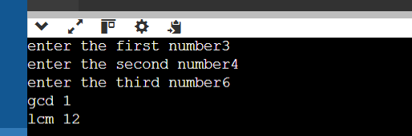

2. write a python program it is leap year or not
year=int(input("enter the number of year"))
if(year%4==0 and year%100!=0) or (year%400==0):
print("leap year")
else:
print("not an leap year")
OUTPUT:
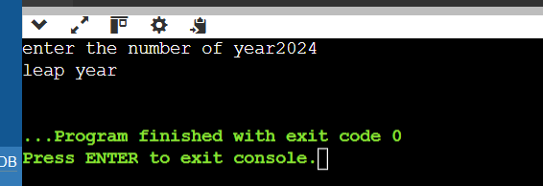
3. write a python program to print the prime numbers between range M to N.
m=int(input("enter the starting number"))
n=int(input("enter the ending number"))
print("prime numbers between",m,"and",n,"are")
for num in range(m,n+1):
if num>1:
for i in range(2,num):
if num%i==0:
break
else:
print( num, end="")
OUTPUT:
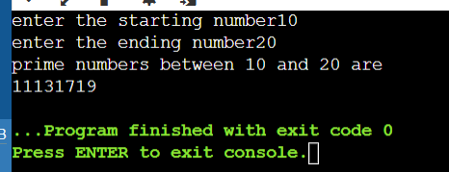

4.WRITE PROGRAM TO PRINT RIGHT TRIANGLE PATTERN USING ‘+’.
rows=int(input("enter the number of rows"))
for i in range(1,rows+1):
print("+" * i)
OUTPUT:
